Logistic Regression in Machine Learning

* Logistic regression is one of the most popular Machine Learning algorithms, which comes under the Supervised Learning technique. It is used for predicting the **categorical(0/1 True False, yes no: binary format ) dependent variable** using a given set of independent variables.
* Logistic regression predicts the output of a categorical dependent variable. Therefore the outcome must be a categorical or discrete value. It can be either Yes or No, 0 or 1, true or False, etc. but instead of giving the exact value as 0 and 1, **it gives the probabilistic values which lie between 0 and 1**.
* Logistic Regression is much similar to the Linear Regression except that how they are used. Linear Regression is used for solving Regression problems, whereas **Logistic regression is used for solving the classification problems**.
* In Logistic regression, instead of fitting a regression line, we fit an "S" shaped logistic function, which predicts two maximum values (0 or 1).
* The curve from the logistic function indicates the likelihood of something such as whether the cells are cancerous or not, a mouse is obese or not based on its weight, etc.
* Logistic Regression is a significant machine learning algorithm because it has the ability to provide probabilities and classify new data using continuous and discrete datasets.
* Logistic Regression can be used to classify the observations using different types of data and can easily determine the most effective variables used for the classification. The below image is showing the logistic function:

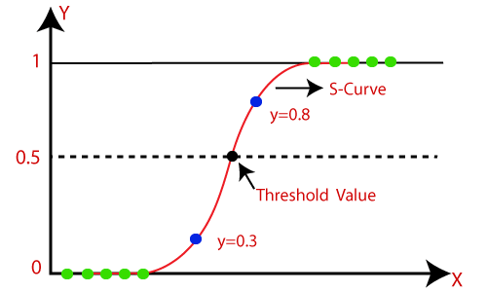

Logistic Function (Sigmoid Function):

* The sigmoid function is a mathematical function used to map the predicted values to probabilities.
* It maps any real value into another value within a range of 0 and 1.
* The value of the logistic regression must be between 0 and 1, which cannot go beyond this limit, so it forms a curve like the "S" form. The S-form curve is called the Sigmoid function or the logistic function.
* In logistic regression, we use the concept of the threshold value, which defines the probability of either 0 or 1. Such as values above the threshold value tends to 1, and a value below the threshold values tends to 0.

Assumptions for Logistic Regression:

* The dependent variable must be categorical**(Binary format**) in nature.
* It should form S-curve
* The independent variable should not have multi-collinearity.

Logistic Regression Equation:

The Logistic regression equation can be obtained from the Linear Regression equation. The mathematical steps to get Logistic Regression equations are given below:

* We know the equation of the straight line can be written as:

Logistic Regression in Machine Learning

**Y = m1x1 +m2x2+m3x3…..mnxn+c**

* In Logistic Regression y can be between 0 and 1 only, so for this let's divide the above equation by (1-y):

Logistic Regression in Machine Learning

* But we need range between -[infinity] to +[infinity], then take logarithm of the equation it will become:

Logistic Regression in Machine Learning

Y_pred = (1/1+e^(-y)) we get prediction

Here y = mx +c

The above equation is the final equation for Logistic Regression.

Performance Measures of Classification.

* **Classification Accuracy:** It is one of the important parameters to determine the accuracy of the classification problems. It defines how often the model predicts the correct output. It can be calculated as the ratio of the number of correct predictions made by the classifier to all number of predictions made by the classifiers. The formula is given below:  
  Confusion Matrix in Machine Learning
* **Misclassification rate:** It is also termed as Error rate, and it defines how often the model gives the wrong predictions. The value of error rate can be calculated as the number of incorrect predictions to all number of the predictions made by the classifier. The formula is given below:  
  Confusion Matrix in Machine Learning
* **Precision:** It can be defined as the number of correct outputs provided by the model or out of all positive classes that have predicted correctly by the model, how many of them were actually true. It can be calculated using the below formula:  
  Confusion Matrix in Machine Learning
* **Recall:** It is defined as the out of total positive classes, how our model predicted correctly. The recall must be as high as possible.  
  Confusion Matrix in Machine Learning
* **F-measure:** If two models have low precision and high recall or vice versa, it is difficult to compare these models. So, for this purpose, we can use F-score. This score helps us to evaluate the recall and precision at the same time. The F-score is maximum if the recall is equal to the precision. It can be calculated using the below formula:  
  Confusion Matrix in Machine Learning